Its Time consuming process if 1000 s of server running in any environment and among all of one server is down or either crash so we want stack trace of that server ,so that we can identify what is actual problem for that purpose we need monitoring system to help us out from that issue .

For analysis of log . Its call log analysis either its centralized or decentralized.

There are a lot of monitoring applications ,one of it is ELK stack.

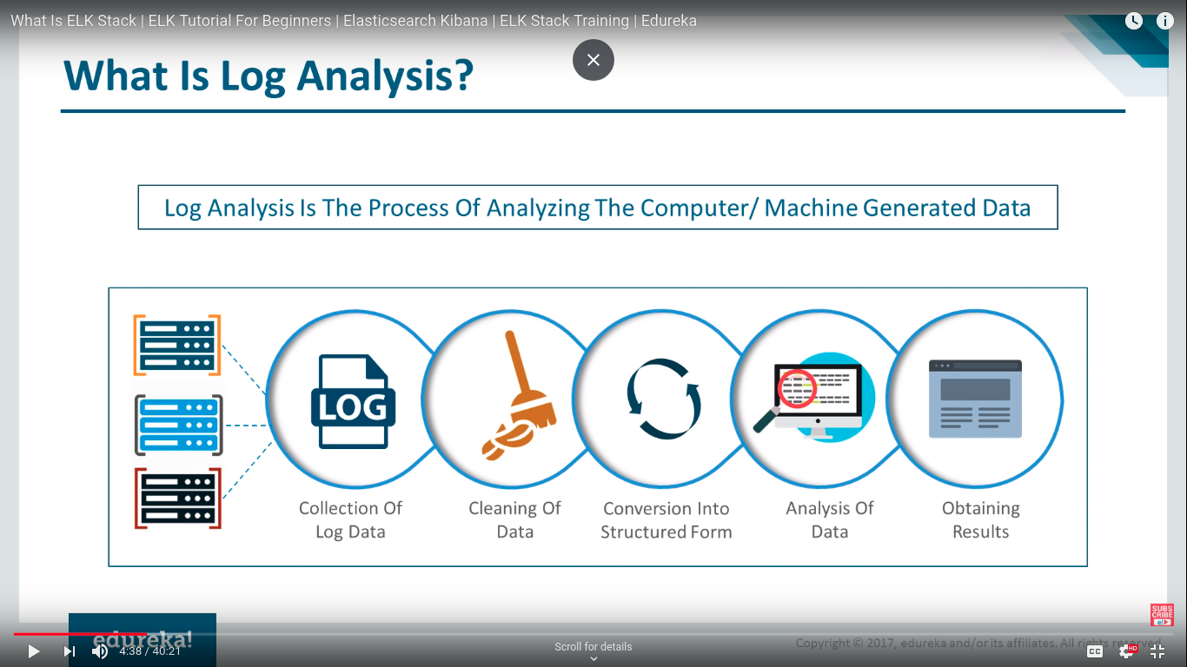

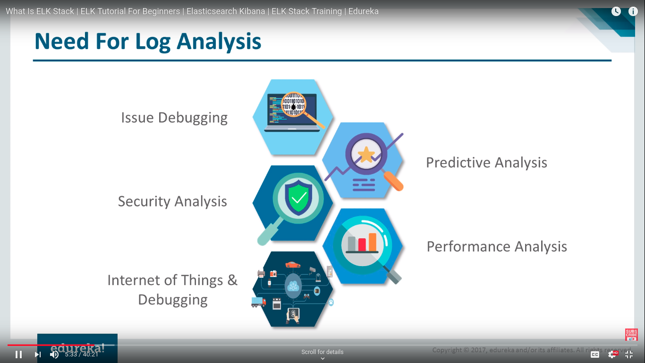

For performace issues checking via analysis of logs

if application depends upon another app then we used IOT for this

problems in log analysis::

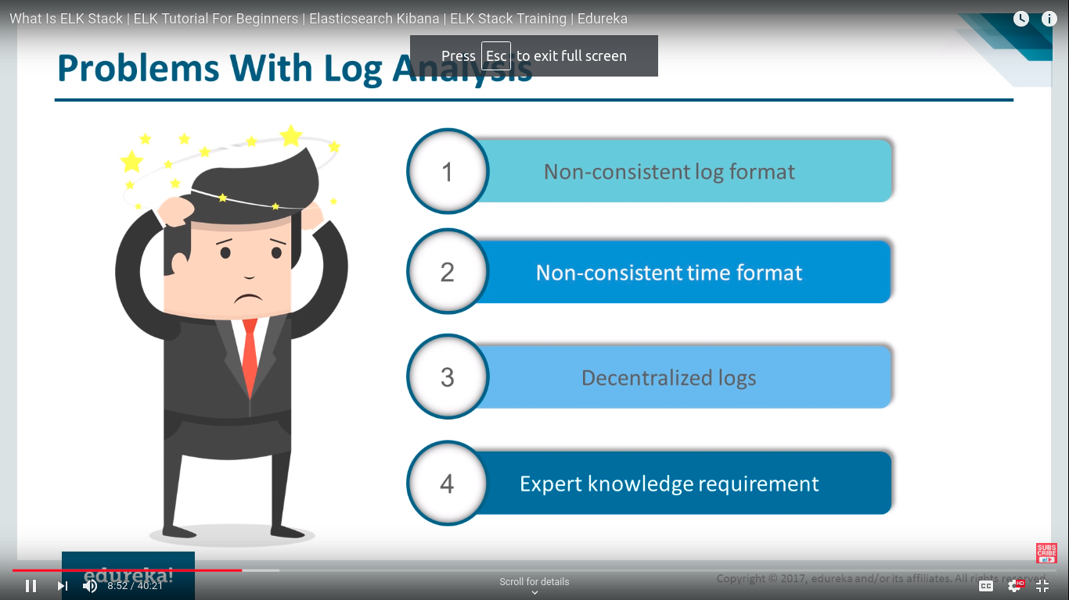

its gone tough if envirmonent in decentrailze means application deployed in different servers like tomcat ,jetty etc or either different langugaes

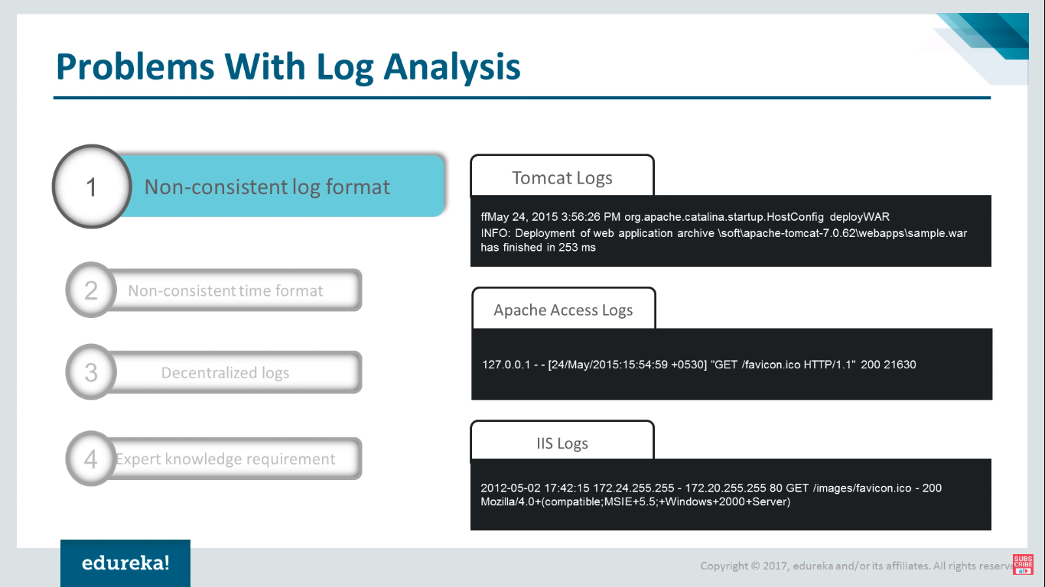log management tools in market::

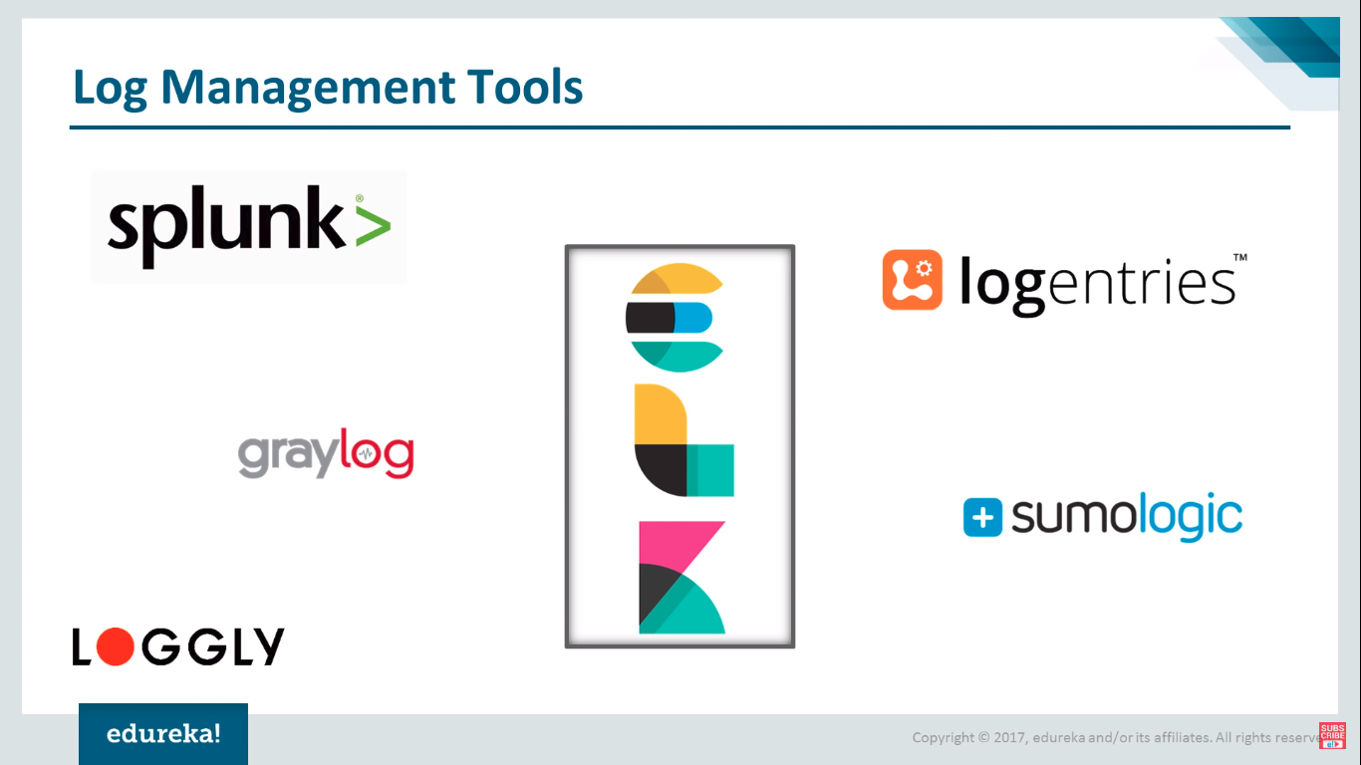

elk stack is combination of::

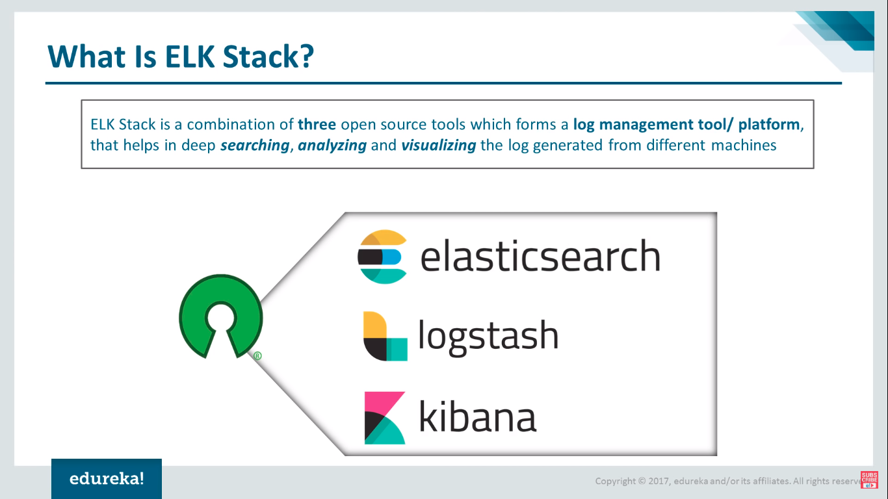

Features of elkss::

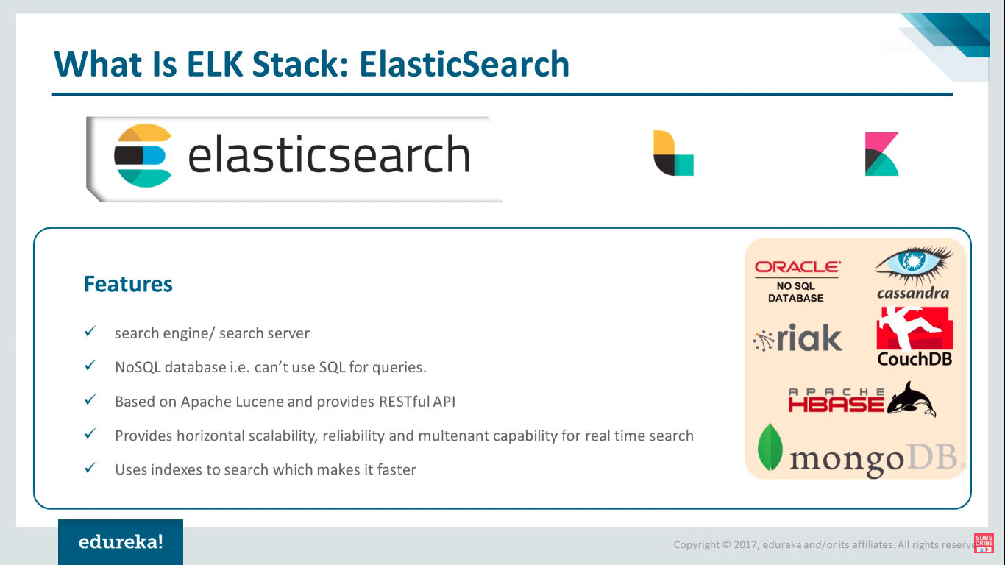

Elestic search::

genrally collecting data via elactic search ,its convert data into data is based on nosql data,provide rest data.

Sarching and indexing fast .

Uses index so searching is fast

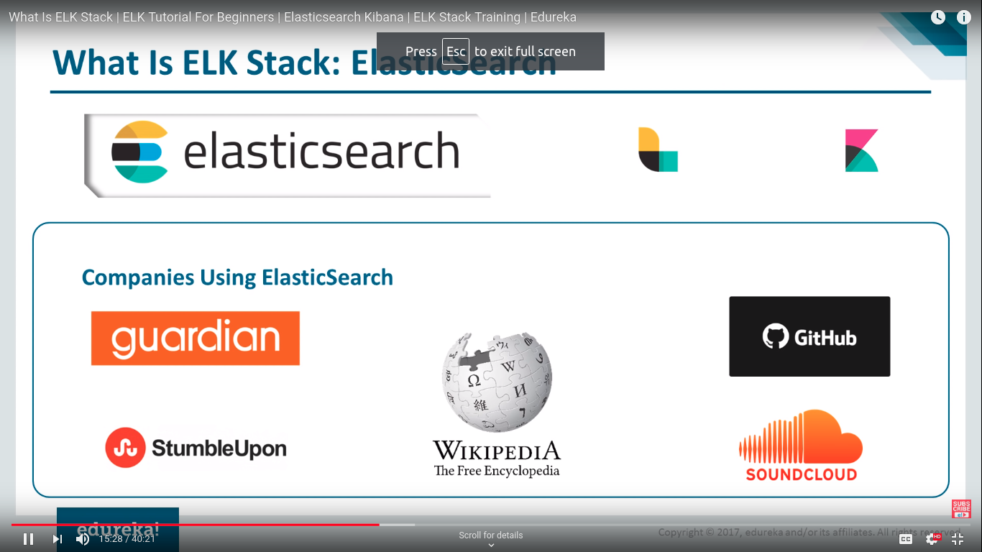companies usages elastic searching::

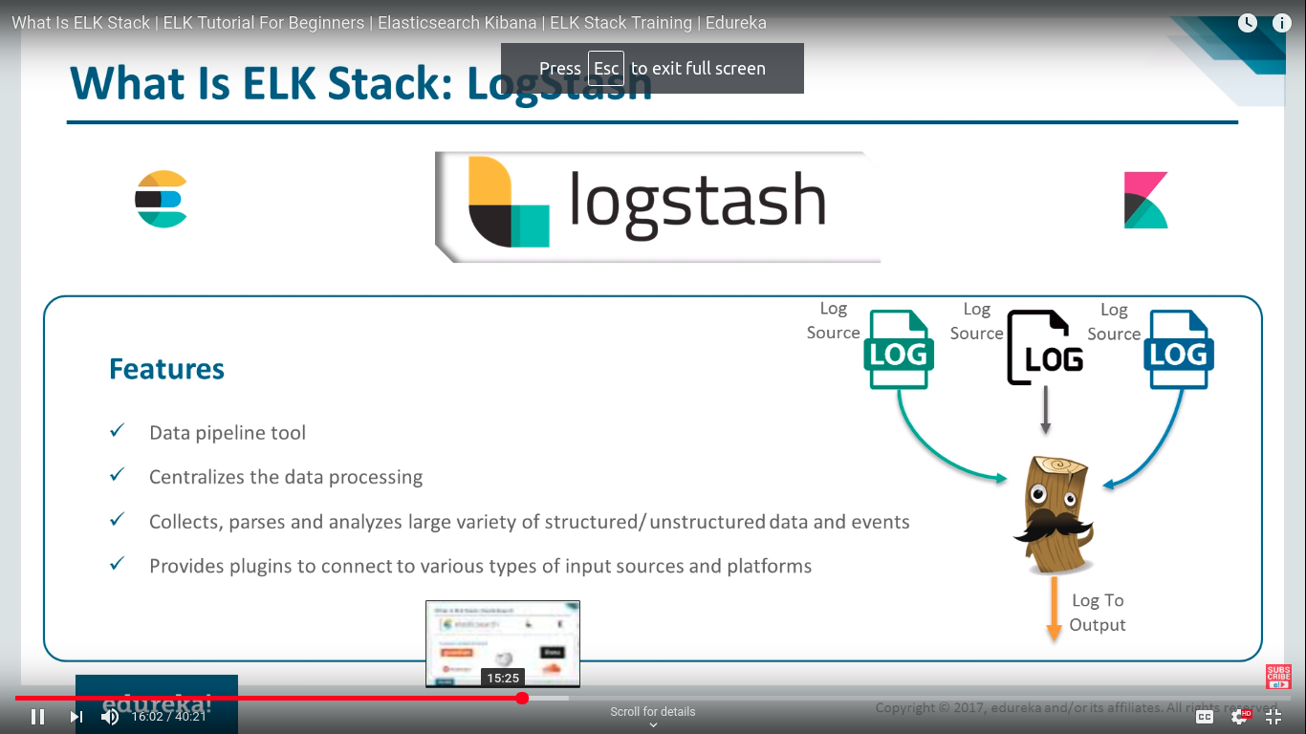Logstash tools::  
coolecting and centralize logs by pulling ,then on center elastic search opertion permform on it. Collect parse the data via log stash

it as data pipeline

Kibana ::

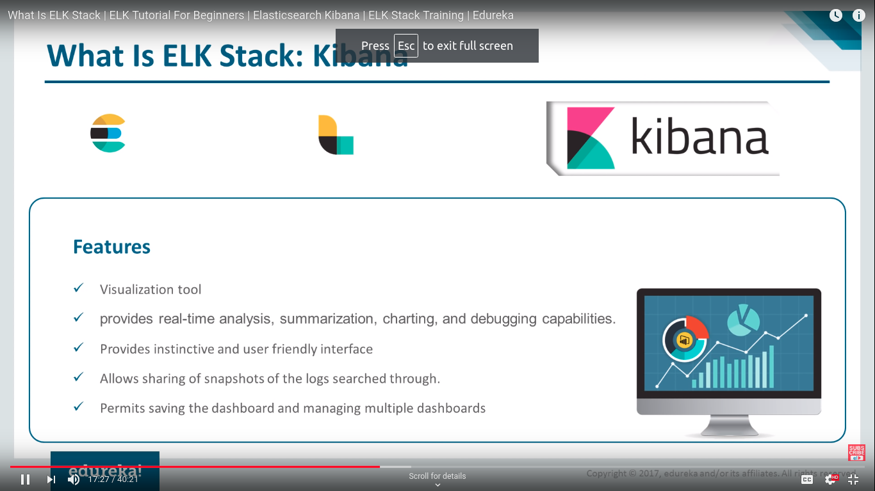

providing visual web platform of logs ,like charting summarazing, graphs

provide handsome report

its a visualization tool.

How elk stack work::

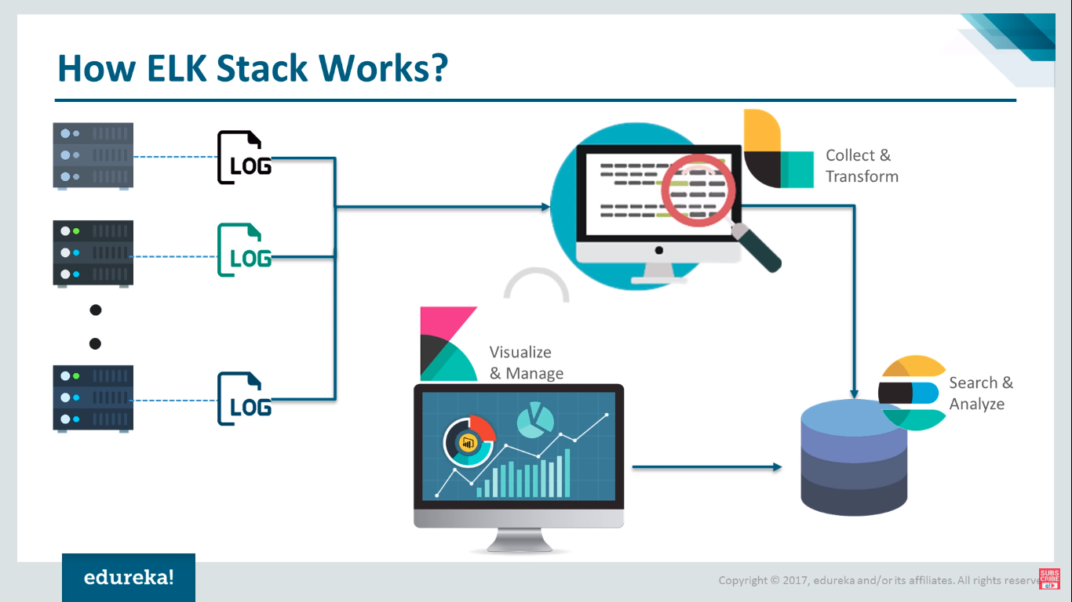

companies using elk stack::

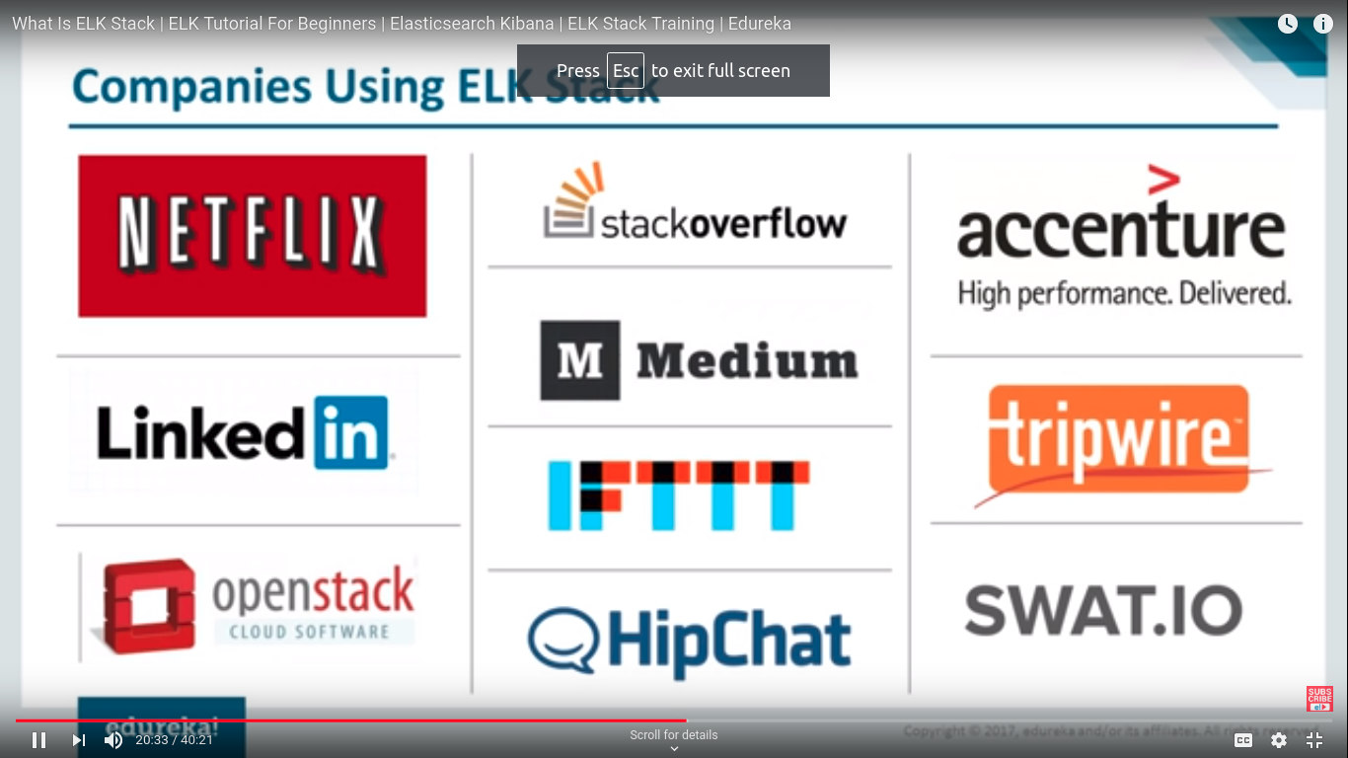

puppet master and puppet node logs::

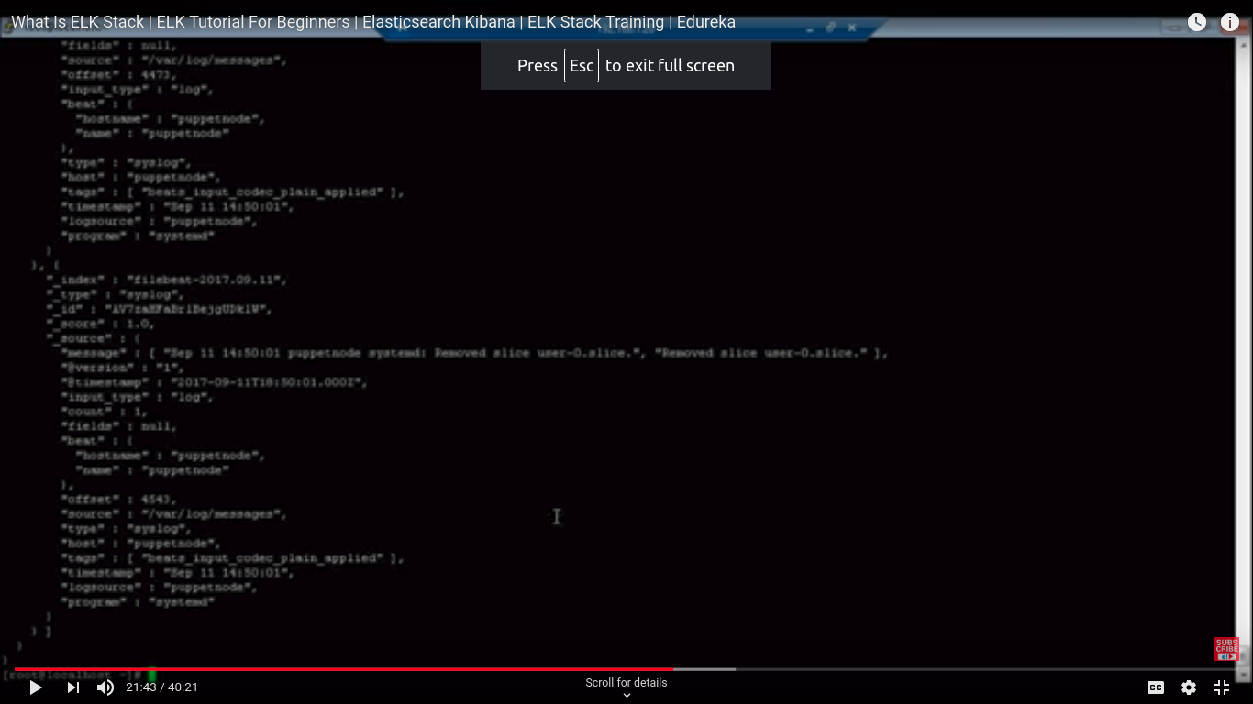

kibana dashboard::

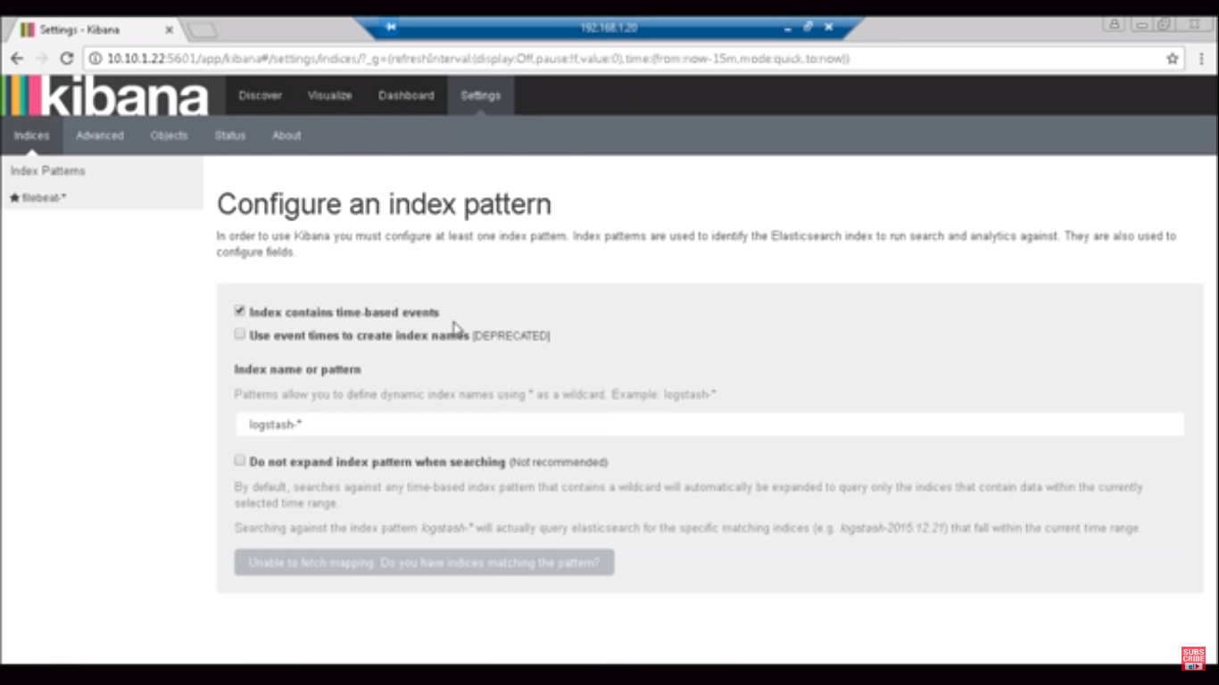

now index for fetching logs from particular sysout like in snapshot he configured through filebeat.\*, and using time based events

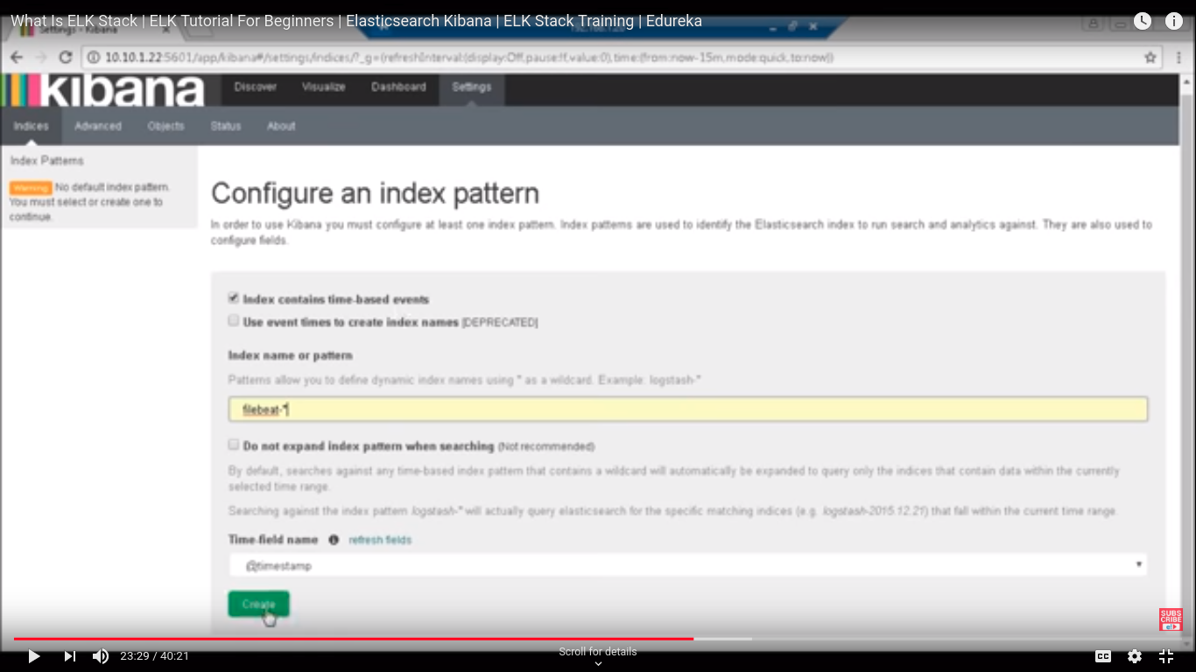

dicovery dashboard::main page

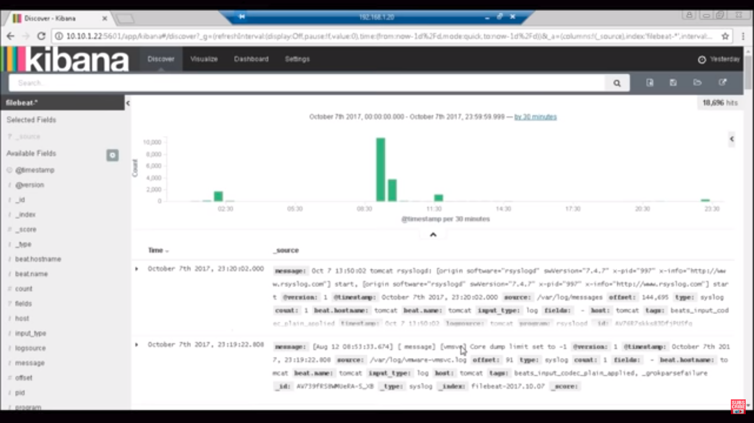‘

visulaization for presentation logics

you can customize also your dashboard..

in future you also export data so memory constraint not showing

in kibana dashboard you can also used queries::

time synch should be good from different ntp servers..